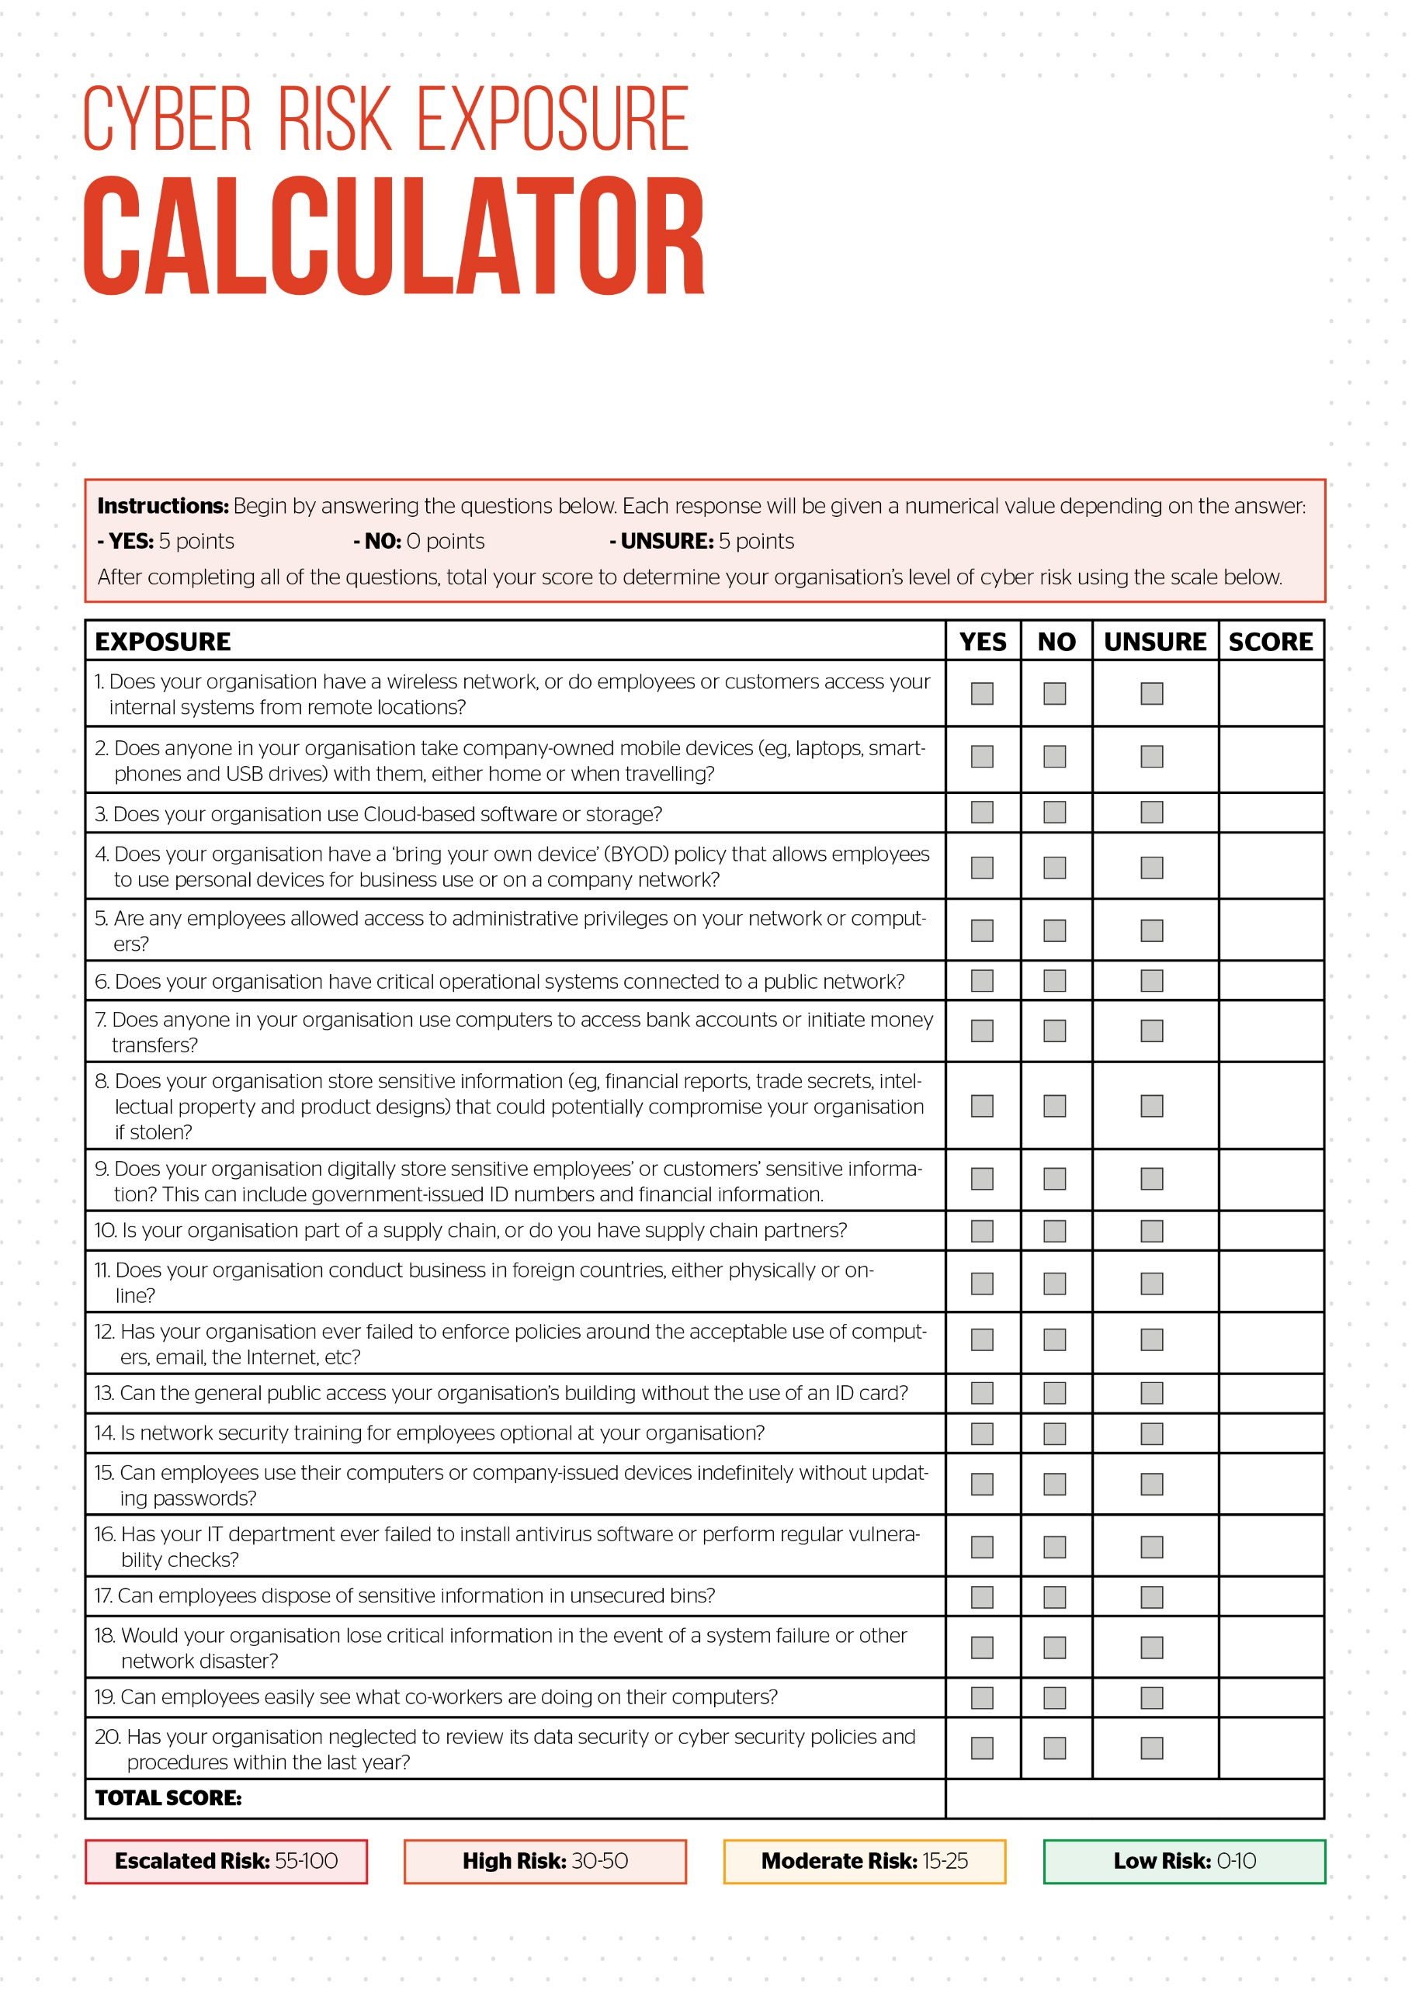

In recent years, cyber attacks have emerged as one of the most significant threats facing organisations of all sizes. The Internet and other network operations have created risks that were non-existent less than a decade ago. When cyber attacks (such as data breaches and hacks) occur, they can result in devastating damage, such as business disruptions, revenue loss, legal fees, a permanently tainted reputation, and more.

It is important to remember that no organisation is immune to the impact of cyber crime. As a result, cyber liability insurance has become an essential component to any risk management programme.

© 2016 Zywave, Inc. All rights reserved.